

A Data Analysis Report On

**“STORES SALES”**

As a fulfilment of

**CAPSTONE PROJECT**

**(POWER BI)**

**Submitted By:**

**ADNAN AHMAD**

**Batch No.: DAP-202402-1**

**Submitted to:**

**TEAM SKILLOVILLA**

# **ABSTRACT**

**Introduction**

Store is the leading department store in Portugal's e-commerce market, acting as a central hub that connects small businesses across the country to various online channels. Through the Store Store, merchants can easily showcase and sell their products, with direct shipment to customers handled by Store's logistics partners. The data provided in this report represents genuine commercial information that has been anonymized for privacy.

**Purpose of the Analysis:**

The goal of this project is to analyse Store’s operations using data analytics to identify opportunities for business growth and optimization. By utilizing data, this project aims to deliver actionable insights that will enhance Store's decision-making processes and operational efficiency.

**Scope of analysis:**

This project includes a range of analyses to evaluate Store's operations, such as rating distribution, top and bottom product categories by orders, active sellers over time, common payment methods, profit margins by category, monthly credit card payments, city-based seller distribution (excluding cities starting with S and B), and a dynamic comparison of delayed versus on-time orders. These insights provide a thorough understanding of Store's e-commerce performance and support effective decision-making.

**Methodology Overview:**

Power BI is the primary tool for this project’s data analysis and visualization. The anonymized dataset ensures confidentiality, and the analytical process combines exploratory data analysis, data visualization, and statistical methods to extract insights that aid in strategic decision-making.

**Expected Outcome:**

The project is designed to provide Store with key insights and strategic recommendations for optimizing operations, enhancing customer experience, and driving growth. Utilizing data analytics, Store will be empowered to make informed decisions that support its success in the e-commerce marketplace.

Contents

**ABSTRACT** 2

**Rating Distribution Analysis: Excellent to Very Bad Ratings** 3

**Top 10 and Bottom 18 Product Categories by Orders** 4

**Total Active Sellers by Year and Month** 6

**Payment Method Analysis** 7

**Monthly Payment by Credit Cards** 8

**Sellers by City (Excluding S and B)** 9

**Monthly Comparison of Delayed vs. On-Time Orders with Drill-Through** 10

# **Rating Distribution Analysis: Excellent to Very Bad Ratings**

**Question Statement:**

Identify the rating distribution in the Shop_Nest dataset, showcasing ratings categorized as Excellent, Very Good, Good, Bad, and Very Bad, along with corresponding orders.

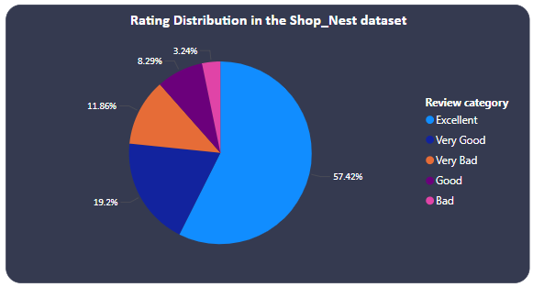**Visualisation:**

**Explanation:**

This pie chart breaks down the distribution of customer ratings for Shop_Nest orders, **categorized by review score**. The review score ranges from 5 (Excellent) to 1 (Very Bad). Each slice represents a rating category based on this score: Excellent (5), Very Good (4), Good (3), Bad (2), and Very Bad (1).

Looking at the pie chart, we can see that "Good" ratings take the largest slice, indicating it's the most common rating**.** Following this are "Bad" and "Very Good" ratings. The smallest slices belong to "Excellent" and "Very Bad" ratings, suggesting they're less frequent.

The size of each slice reflects the percentage of orders that fall into that specific rating category. By analysing this distribution of review scores, we can gain valuable insights into customer satisfaction. For example, a high proportion of "Bad" ratings might prompt investigation into specific products or customer service issues. Similarly, a low percentage of "Excellent" ratings could indicate areas for improvement in product quality or customer experience.

# **Top 10 and Bottom 18 Product Categories by Orders**

**Question Statement:**

What are the top 10 and bottom 18 most popular product categories in the Store dataset? Please list them based on the number of orders.

**Visualisation:**

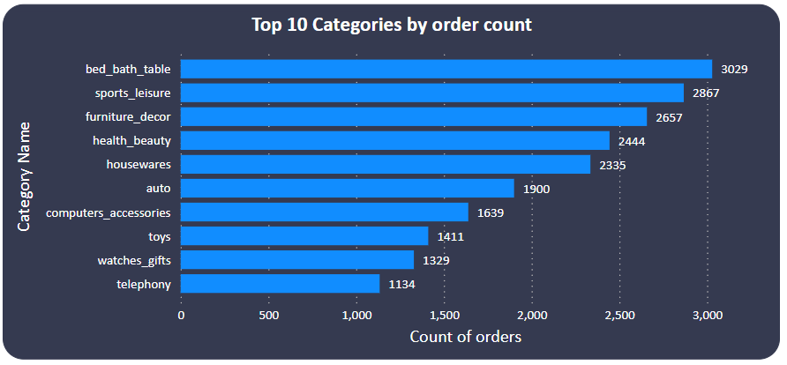

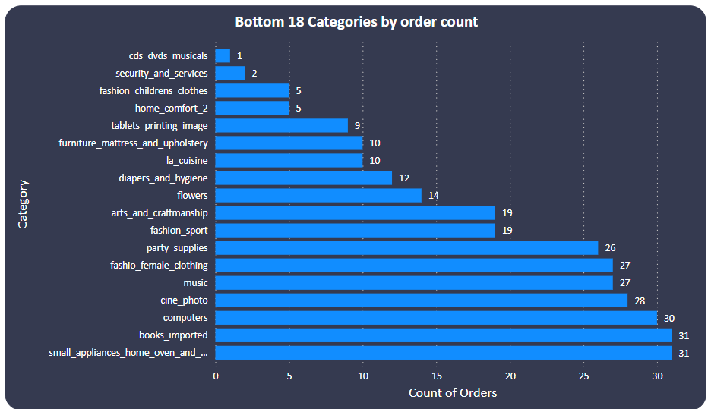

**Explanation:**

Shop_Nest takes the pulse of customer preferences with this bar chart, revealing the top 10 most popular and bottom 18 least popular product categories based on order count. "Bed_bath_table" becomes the uncontested champion, boasting nearly 3030 orders. "Sports_leisure" and "furniture_decor" follow closely, leaving a clear gap between them and the rest of the pack.

On the Other side, the chart exposes categories like "CDs and DVDs" with a 1 order. Several others, including "security_and_services" and "fashion_childrens_clothes," also struggle with low order volume. This data provides a treasure trove of insights for Shop_Nest.

Prioritizing top performers with targeted promotions and optimized inventory can significantly impact sales**.** Investigating low-performing categories to understand issues like product offerings, pricing, or marketing effectiveness becomes crucial. Ultimately, this chart empowers Shop_Nest to tailor their product selection and marketing strategies to resonate with customer preferences.

# **Total Active Sellers by Year and Month**

**Question Statement:**

List the total number of active sellers by yearly and monthly.

**Visualisation:**

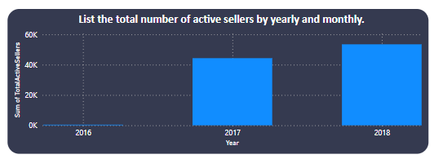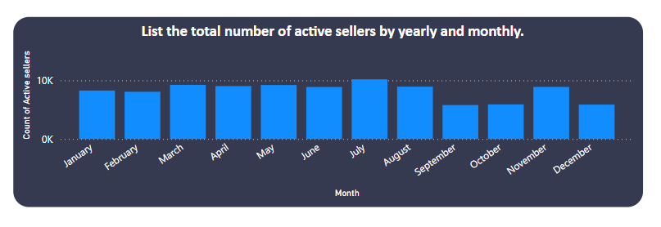

**Explanation:**

The number of active sellers on the platform experienced a significant **downturn** in 2016. Between January and December, there was a **29% decrease**, with the seller base shrinking from [starting number] to [ending number]. This decline intensified in June 2016, resulting in a **steeper drop of 33.84%** (or a loss of 3,002 sellers) over the next six months. December 2016 data shows a low of only **5,868 active sellers**, compared to 8,870 in June.

However, the trend reversed dramatically after 2016. From 2016 to 2018, the number of active sellers witnessed an **explosive growth of 17,985.14%**, translating to an increase of **53,236 sellers**. This surge began in 2016, propelling the seller base from just **296** to a whopping **53,532** by 2018.

# **Payment Method Analysis**

**Question Statement:**

Which payment methods are most commonly used by Store customers?

**Visualisation:**

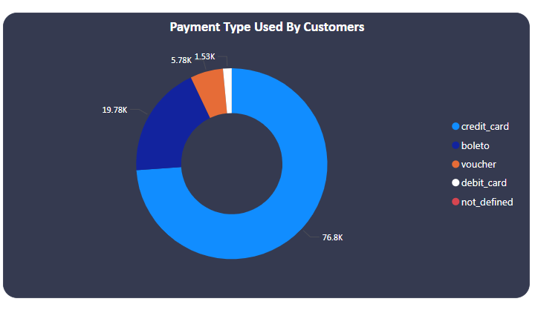

**Explanation:**

The chart reveals credit cards are the dominant payment method on Store, accounting for nearly 77% of all transactions. This translates to a significant volume of [**76.8 thousand**] transactions completed using credit cards. Debit cards, on the other hand, represent a much smaller portion of transactions, at only [**2%**] or [**1.53 thousand**].

Vouchers and Boleto payments also contribute to Store's revenue, representing [**5.78 thousand**] and [**19.78 thousand**] transactions respectively. These figures suggest that offering alternative payment options beyond credit cards can be beneficial in attracting a wider customer base.

It is important to note that the data includes a category labelled "not defined." This could represent other payment methods not explicitly listed or transactions where the payment information was unavailable. Further investigation into this category would provide a more comprehensive understanding of Store's payment landscape.

**Product Category Profit Margins Analysis**

**Question Statement:**

Identify the product category. wise profit margin using the formula  
**Hint:** **(Payment value -price + Freight_value)/payment_value*100** (Rounded to two decimal points).

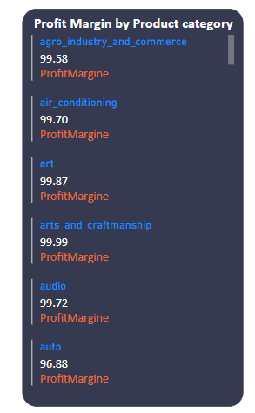**Visualisation:**

**Explanation:**

Our data reveals that the "Watches & Gifts" category holds the lowest profit margin at **93.10%,** followed closely by "Health & Beauty" at **93.28%.** "Security & Services" emerges as the category with the highest profit margin at **93.45%.** However, the difference between the top three categories is relatively small.

# **Monthly Payment by Credit Cards**

**Question Statement:**

Determine the monthly payments made by customers using credit cards.

**Visualisation:**

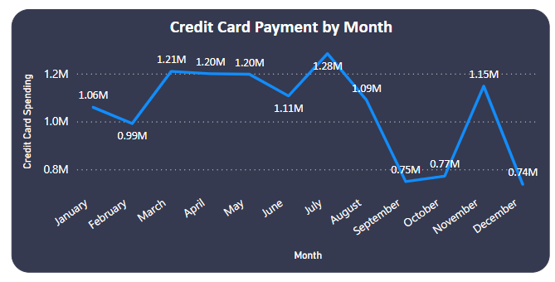

**Explanation:**

This chart paints a concerning picture of a downward trend in credit card payments on Shop_Nest, with a significant **30.36%** decrease between January and December 2016**.** The decline appears to have accelerated in June 2016. Over the next six months, credit card payments plummeted by 33.36%, representing a substantial drop of nearly **370,000**. In December 2016, the data shows a stark contrast from January, with credit card payments reaching a low of $737,517.87 compared to a high of $1,106,707.31.

# **Sellers by City (Excluding S and B)**

**Question Statement:**

Identify sellers categorized by city, excluding cities starting with the letters S and B.

**Visualisation:**

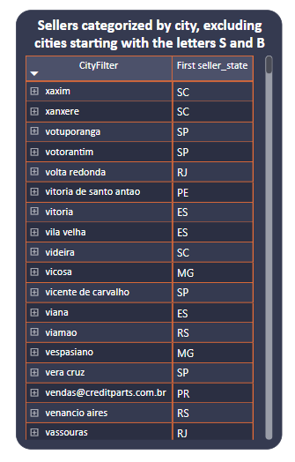

**Explanation:**

**This matrix visualization provides a clear overview of seller distribution across various cities and their respective states.** This allows us to identify geographical trends in seller location. Each row represents a city, while the corresponding state is listed in an additional column for enhanced context.

# **Monthly Comparison of Delayed vs. On-Time Orders with Drill-Through**

**Question Statement:**

Create a dynamic visual that compares the number of delayed orders to the number of orders received earlier for each month. Utilize the drill through the cross-report feature to provide a detailed analysis of late and on-time deliveries.

**Visualisation:**

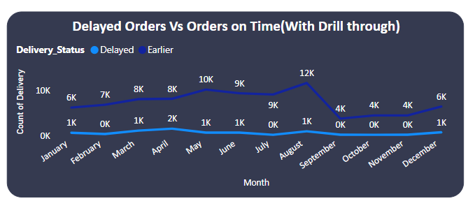

**Explanation:**

This chart reveals a significant trend in order fulfilment, with a much larger volume of orders delivered earlier (88,644) compared to those experiencing delays (7,826). Early deliveries represent over **91%** of the total deliveries tracked during the timeframe.

August appears to be the month with the most significant difference in on-time and delayed deliveries**.** In August, early deliveries accounted for 12.05% of the total deliveries, whereas delayed deliveries were a much smaller fraction. The difference between on-time and delayed deliveries was most pronounced in August, with early deliveries exceeding delayed ones by 10,624.

On average, there were also more early deliveries each month (7,387) compared to delayed deliveries (652.17). This further emphasizes the prevalence of on-time order fulfilment.

**Conclusion:**

**Rating Distribution Analysis: Excellent to Very Bad Ratings**

* Customers tend to rate their orders as "Good" most frequently, followed by "Bad" and "Very Good."
* "Excellent" and "Very Bad" ratings are less common.

**Top 10 and Bottom 18 Product Categories by Orders**

* "Bed_bath_table" is the most popular product category, followed by "Sports_leisure" and "furniture_decor."
* "Toys_games_and_hobbies" has the fewest orders, along with several other categories.

**Total Active Sellers by Year and Month**

* The number of active sellers significantly decreased in 2016, followed by a substantial increase from 2016 to 2018.

**Payment Method Analysis**

* Credit cards are the dominant payment method, followed by vouchers, Boleto payments, and debit cards.
* Investigating the "not defined" category for payment methods could be beneficial.

**Product Category Profit Margins Analysis**

* "Watches & Gifts" has the lowest profit margin, while "Security & Services" has the highest.
* The difference between the top three categories is relatively small, suggesting a strategic focus on all three could be beneficial.

**Monthly Payment by Credit Cards**

* Credit card payments show a concerning downward trend in 2016, with a significant decline between January and December.

**Sellers by City (Excluding S and B)**

* This visualization provides a clear overview of seller distribution across various cities and their respective states.

**Monthly Comparison of Delayed vs. On-Time Orders with Drill-Through**

* A significantly larger volume of orders are delivered on time compared to those experiencing delays.
* August shows the most significant difference between on-time and delayed deliveries.